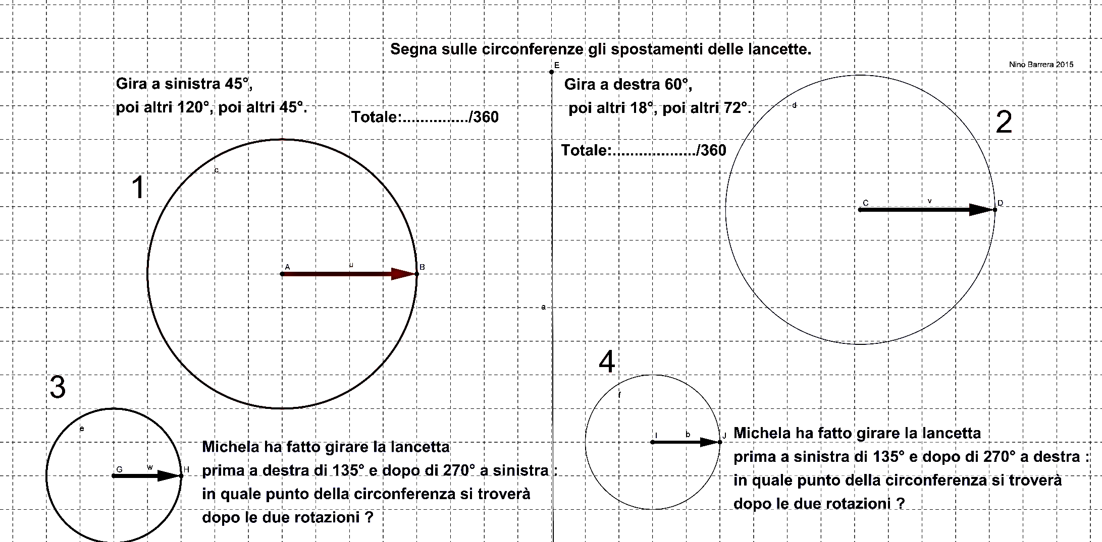

Alunn__ __________________________________________________________Classe________________Data________________________________________
Spazio per i tuoi calcoli

